***Prediction of Loan Approval using***

***Logistic regression***

**Abstract:**

Loan approval prediction plays a pivotal role in the banking sector, aiding financial institutions in making informed decisions while minimizing the risk of default. In this study, we investigate various machine learning techniques for enhancing loan approval prediction models. Leveraging a dataset consisting of historical loan data, we employ logistic regression, SVM, KNN, among other models, to develop predictive models. Model performance is evaluated using accuracy metrics, classification reports, precision, recall, and F1-score. Our findings shed light on the effectiveness of different models in accurately predicting loan approval outcomes and provide insights into factors influencing model performance.

**Introduction:**

Loan approval prediction is a critical task in the banking sector, with significant implications for financial institutions and customers alike. In recent years, machine learning techniques have gained prominence for their ability to improve the accuracy and efficiency of loan approval processes. In this study, we aim to enhance loan approval prediction models by evaluating various machine learning algorithms and techniques.

**Methodology:**

We collected a dataset consisting of historical loan data, including attributes such as credit score, income, loan amount, and loan status (approved or denied). We employed logistic regression, SVM, KNN, and other machine learning algorithms to develop predictive models. Model performance was evaluated using accuracy metrics, classification reports, precision, recall, and F1-score.

**Results:**

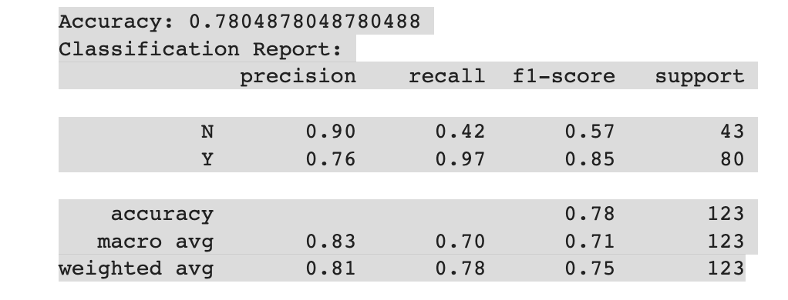

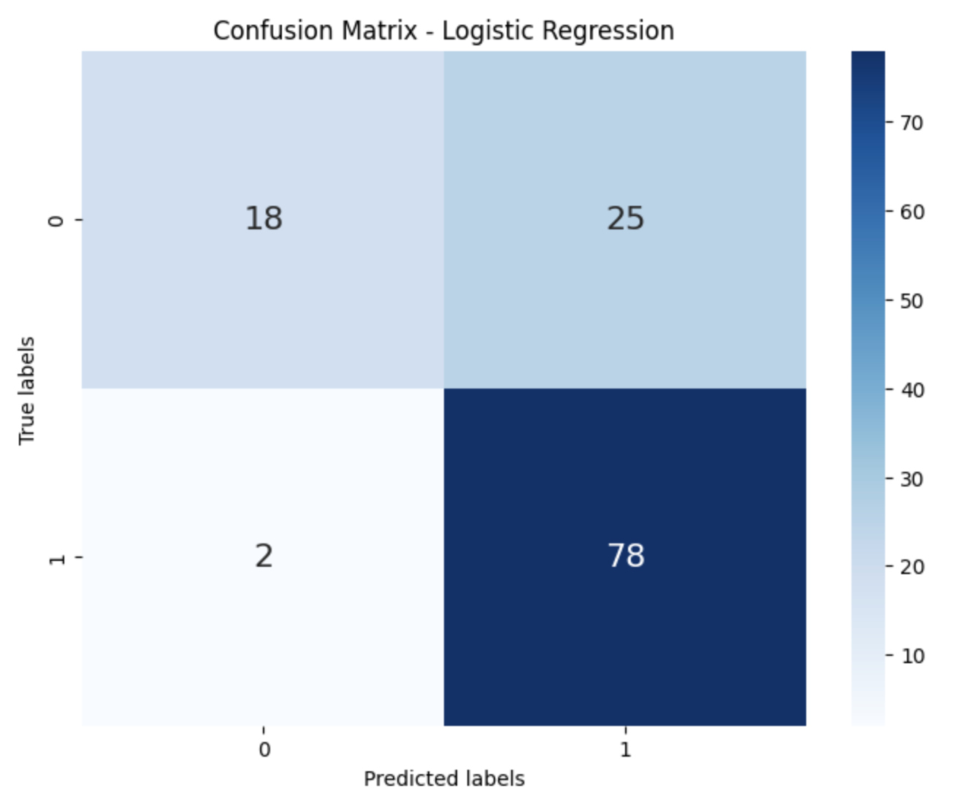

Our analysis revealed that the logistic regression model achieved an accuracy of 0.78, with a precision of 0.76 and recall of 0.97 for approved loans. SVM and KNN models also demonstrated competitive performance, with varying degrees of accuracy and precision. Classification reports further highlighted the strengths and weaknesses of each model, providing valuable insights into their predictive capabilities.

**Conclusion:**

In conclusion, our study provides a comprehensive analysis of loan approval prediction models, highlighting the effectiveness of different machine learning techniques. While logistic regression emerged as a promising approach, SVM and KNN also showed potential for improving loan approval prediction accuracy. By leveraging these insights, financial institutions can optimize their loan approval processes, minimizing the risk of default while enhancing customer satisfaction.

**References:**

[1] Toby Segaran, "Programming Collective Intelligence: Building Smart Web 2.0 Applications," O'Reilly Media.

[2] Bing Liu, "Sentiment Analysis and Opinion Mining," Morgan & Claypool Publishers, May 2012.

[3] Raj, J. S., & Ananthi, J. V., "Recurrent neural networks and nonlinear prediction in support vector machine," Journal of Soft Computing Paradigm (JSCP), 1(01), 33-40, 2019.

[4] X.Frencis Jensy, V.P.Sumathi,Janani Shiva Shri, "An exploratory Data Analysis for Loan Prediction based on nature of clients," International Journal of Recent Technology and Engineering (IJRTE),Volume-7 Issue-4S, November 2018.